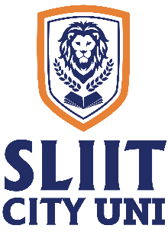
SLIIT CITY UNI

Makeup Final Examination Timetable – On Campus

Year 1 – Semester 2, December 2024
Higher Diploma in Information Technology

Date | Time | Subject
9/12/2024 | 9.30 am – 11.30 am | Database Management Systems (IT1109)
10/12/2024 | 9.30 am – 12.30 pm | Software Engineering (IT1112)
11/12/2024 | 9.30 am – 11.30 am | Web Application Development (IT1201)
12/12/2024 | 9.30 am – 11.30 am | Emerging Technologies and Frameworks (IT1204)
13/12/2024 | 9.30 am – 12.30 pm | Object Oriented Programming (Java) (IT1108)

Academic Affairs Division
Date: 26 November 2024

