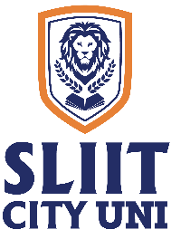
SLIIT CITY UNI

Supplementary Midterm Examination Timetable – On Campus

Year 1 – Semester 1, December 2024

2024 June Intake
Higher Diploma in Business Management

Date | Time | Subject
02/12/2024 | 9.30 a.m. – 10.30 a.m. | Business English & Communication Skills (IT1104) (Online)
02/12/2024 | 1.30 p.m. – 2.30 p.m. | Management Principles (BM1102) (Written)
03/12/2024 | 11.30 a.m. – 12.30 p.m. | Financial Management (BM1109) (Written)
04/12/2024 | 9.30 a.m. – 10.30 a.m. | Business Economics I (BM1108) (Written)
05/12/2024 | 9.30 a.m. – 10.30 a.m. | Business Mathematics (BM1110) (Written)

Academic Affairs Division
Date: 27 November 2024

